Set up **GIT** local repository in **Eclipse** and push to **GITHUB** Remote Repository

**Step 1:**

**Install EGit Plug-in Eclipse**

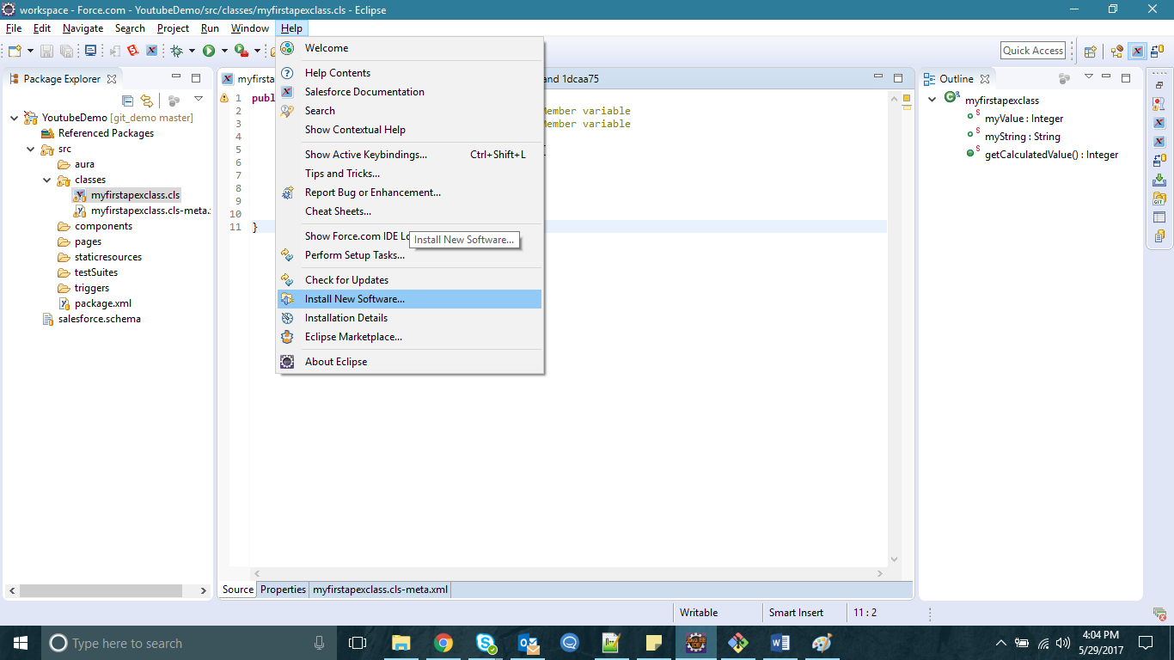

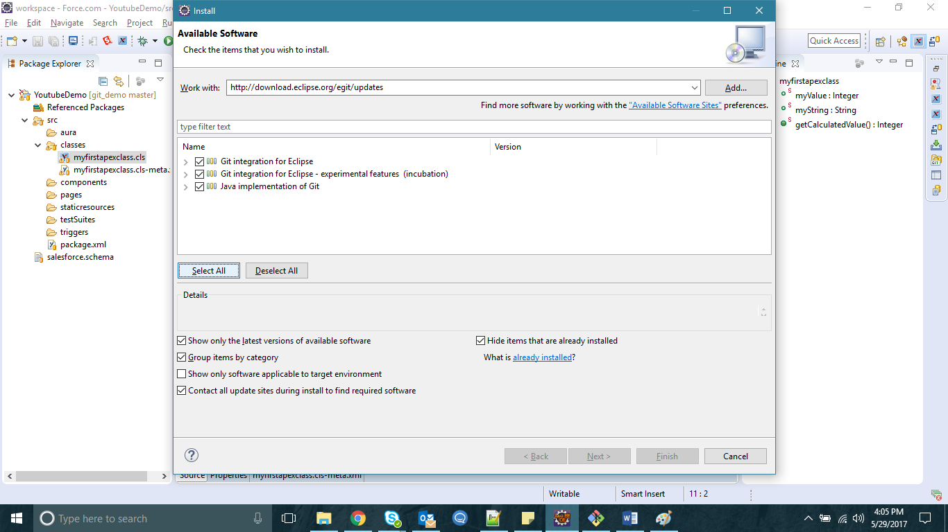

EGit can be installed from the following URL: <http://download.eclipse.org/egit/updates>

**Step 2:**  
Gets the Salesforce code in local workspace using force.com IDE.

**Step 3:**  
Now, configure repository on your local system which is also known as “Local Repository”

Navigate to “Right click on Project | Team | Share Project”

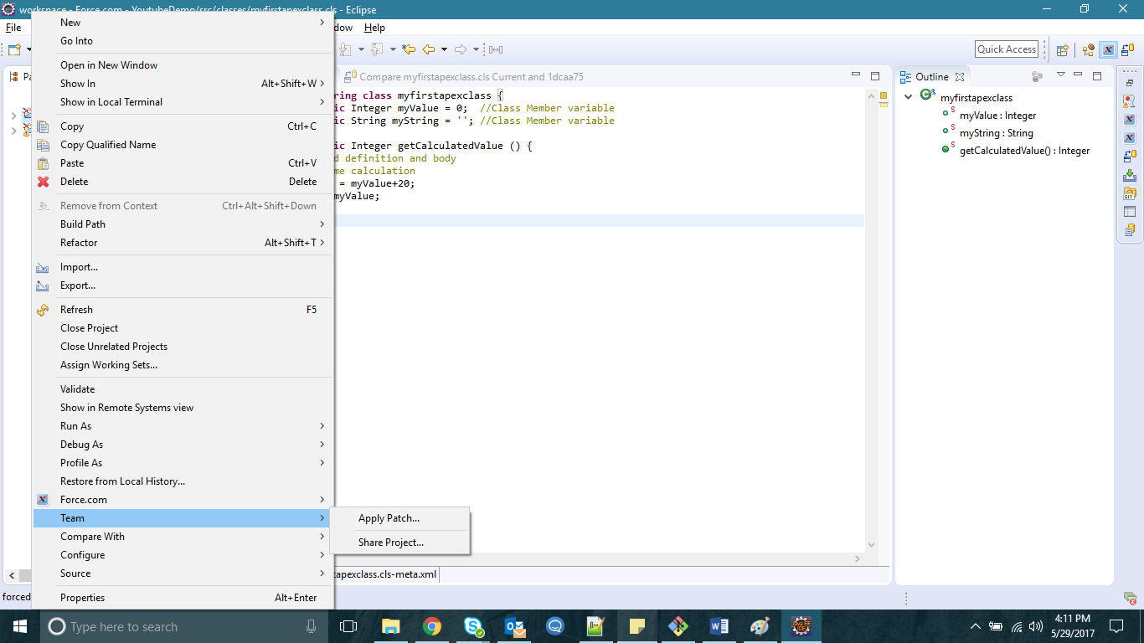

Click on “create” button, a new pop up will open where we can give Local repository name as well as location where we want to save the local repository.

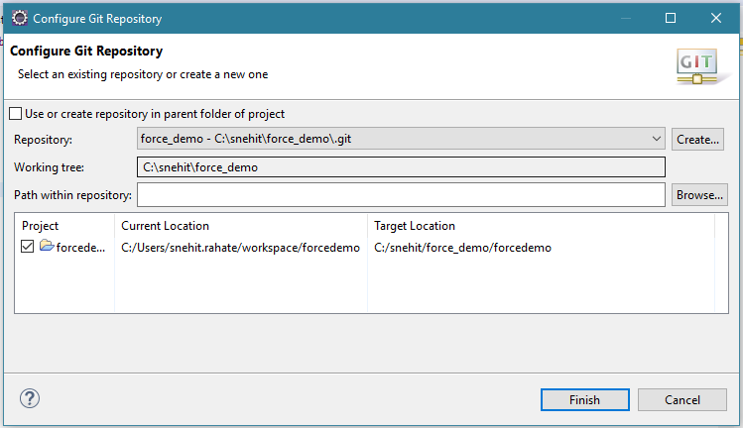

Its will create the project with **?** mark as shown below.



Commit this to local repository

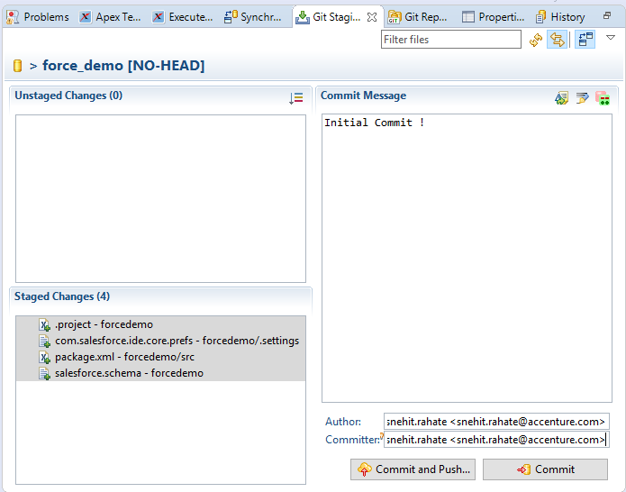

After commit the folder structure will appear with following icons:



**Step 4:**  
Until here, we have done configuration for Local repository. Let’s move on to create a remote repository using **GITHUB**

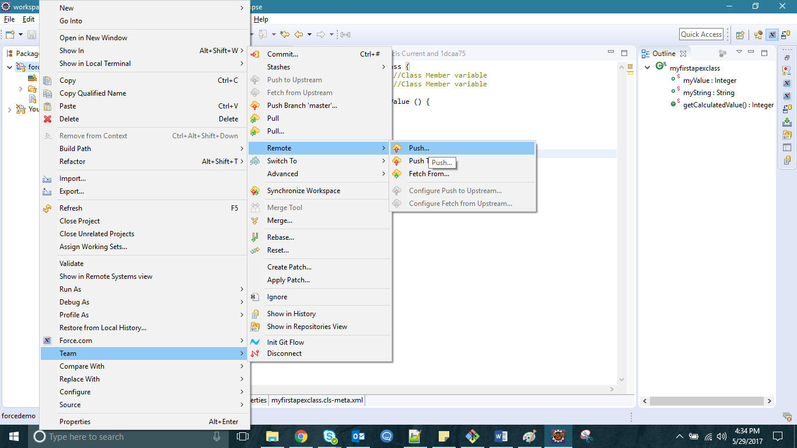

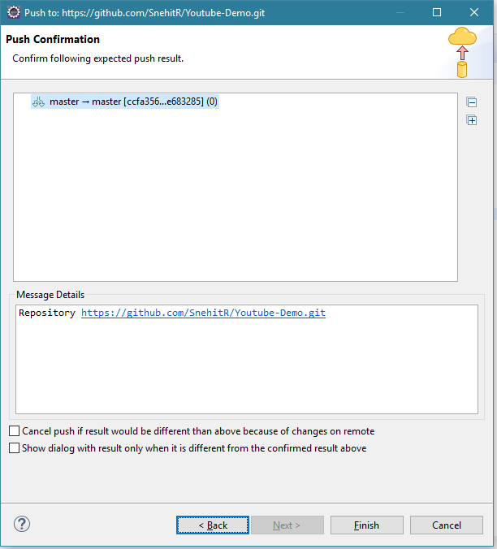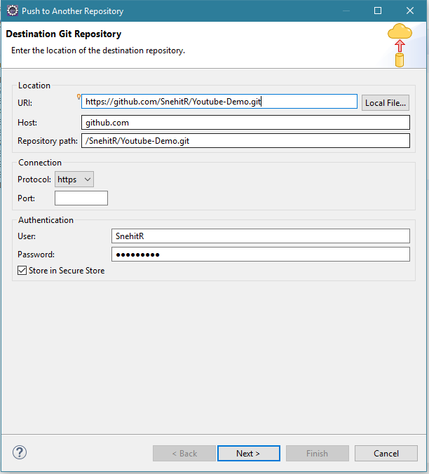

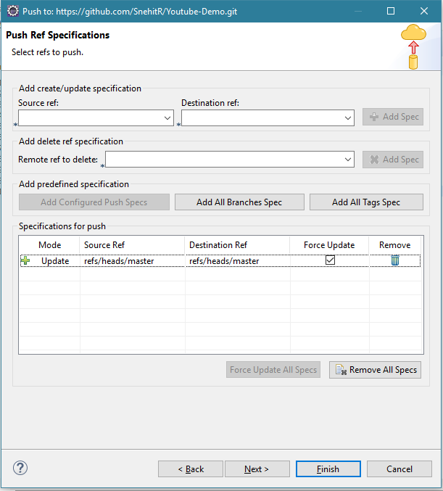

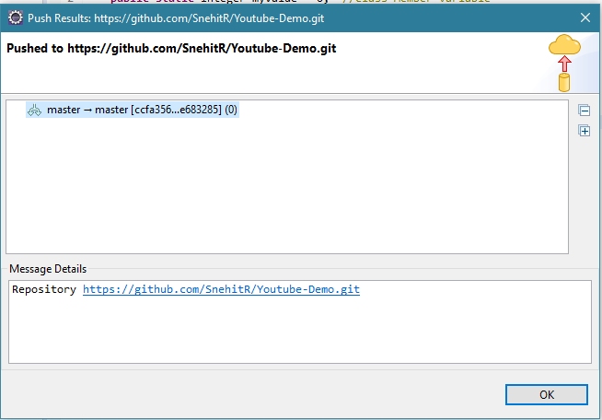

Code is push to Remote repository.

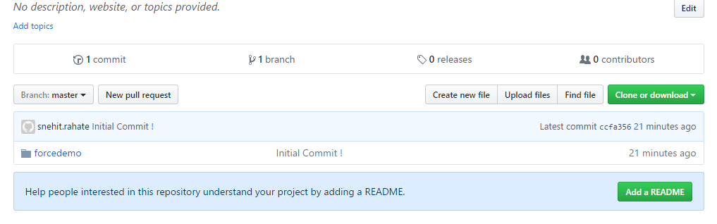

Also we can use compare option to compare various commit and previous revisions.

